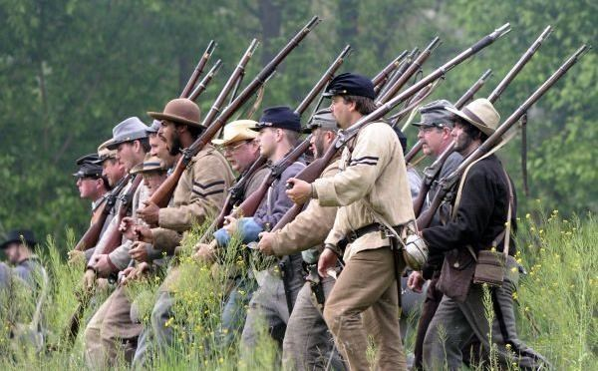
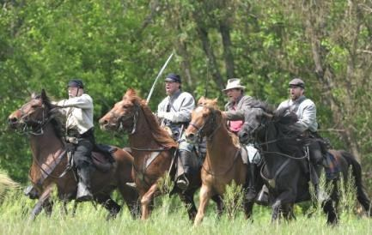
Buchanan Civil War History Weekend
Friday, April 26, Saturday, April 27 & Sunday, April 28, 2024

REGISTRATION FORM
Please fill this form out completely and list everyone who is to participate from your camp, unit or organization. All Forms MUST BE COMPLETED AND SIGNED FOR THIS REGISTRATION TO BE ACCEPTED.
Return all completed forms and payments to: Town of Buchanan, P.O. Box 205, Buchanan, VA 24066.
Completed forms must be received by FRIDAY, MARCH 15, 2024.
CHECK IN - ALL participants must sign in at the Check In Station at the Pavilion next to the restrooms on the Town Park located at 485 Lowe Street. You will receive your Confirmation Wristband at this time with a confirmation wrist band. Confirmation Wristbands must be worn at all times. DO NOT SET UP CAMP UNTIL YOU HAVE GONE THROUGH CHECK IN.
FEES: A nonrefundable flat fee of $15.00 will be charged for each individual, Reenactor.
Reenactors who register after FRIDAY, MARCH 15. 2024 will be charged $20 per person.
There will not be a meal ticket provided after April 12, 2024 registration.
Minors must have a parental release form signed and be accompanied by a parent or guardian.
A $25 Fee for each Period Vendor or Sutler who pre-registers by FRIDAY, MARCH 15, 2024. A $50 Fee will be charged to each vendor or settler who register after this date

Make checks payable to: Town of Buchanan. ALL FEES ARE NON REFUNDABLE.
Unit, Regiment or Sutler: ____________________________________________________________________

Contact Person: ____________________________________________________________________________

Mailing Address: ___________________________________________________________________________

City: _____________________________________ State: ________________ Zip: ______________________

Phone: _______________ Email: _____________________________________________________________

Organization Affiliation (e.g. ANV, Indp.,SCV,UCV) ___________________Branch of Service______

Total Registration Fee Enclosed: __________________________________________________
Note: Participant agrees that participation in Buchanan’s Civil War History Weekend is entirely at own risk and assumes total responsibility for accidents, damages and other claims that result from or during their activities in Buchanan’s Civil War History Weekend or in transit to/or from the event, whether such occur to the owner or third parties. Participant understands that the Town of Buchanan does not assume any responsibility for such liabilities, and Participant agrees to release and hold the Town of Buchanan, its employees Committee harmless. Participant further agrees that participation in Buchanan’s Civil War History Weekend is strictly voluntary and is completely unrelated to work with the Town of Buchanan, VA. Signature of owner denotes agreement to these terms and those in the Event Rules.
Note: All individuals will need to sign a waiver either in advance, or upon arrival on the field, all participants must wear wristband they receive during the check in.

Signature: _______________________________ Date: _______________________

LIST NUMBER OF PARTICIPANTS BY CATEGORY
INFANTRY: (CSA)________________, (USA)____________________

CAVALRY: (C..S. Mounted)___________Horses ___________Dismounted ______________

(U.S. Mounted)___________ Horses___________ Dismounted___________

ARTILLERY: (C.S.A.)_______(No .of Guns)______________(Type/guns)______________

(U.S.)_________(No. Guns)________________(Type Guns)_____________

LIVING HISTORY / OTHER ____________________________ (must be pre-approved)

*Specify Impression and who with__________________________________________________

CIVILIAN IMPRESSIONS (Name) _____________________________Space ____________

Describe presentation _______________________________________ Arrival date __________

Period Sutler (Name)_____________________________ Space Required ______________________

Type merchandise__________________________________ Arrival Date __________________

Email Contact: ____________________________________________________________________________

Minors must have a parental release form signed and be accompanied by a parent or guardian.

Note: All individuals will need to sign a waiver
either in advance, or upon arrival on the field. (If more space for individuals is needed, make a copy of this sheet)

Note: Participant agrees that participation in Buchanan’s Civil War History Weekend is entirely at own risk and assumes total responsibility for accidents, damages and other claims that result from or during their activities in Buchanan’s Civil War History Weekend or in transit to/or from the event, whether such occur to the owner or third parties. Participant understands that the Buchanan Special Events Committee or Town of Buchanan does not assume any responsibility for such liabilities, and Participant agrees to release and hold the Town of Buchanan harmless. Participant further agrees that participation in Buchanan’s Civil War History Weekend is strictly voluntary and is completely unrelated to work with the Town of Buchanan, VA. Signature of owner denotes agreement to these terms.

Print Name: ______________________________

Signature: _________________________________________ Date: ______________________

Phone: _____________________________ Email: _______________________________________________

RETURN COMPLETED FORMS AND PAYMENTS TO:
Town of Buchanan
P.O. Box 205
Buchanan, VA. 24066

Company Muster Roll
All participants, by registering for and attending this event agree that any sponsoring organization, persons, unit or agents or employees thereof will not be held liable or responsible for loss, damage, or injury to persons or property during this event.
PLEASE TYPE OR PRINT NAMES LEGIBLY

RANK _____ NAME ______________________________________ PHONE _____________
Address _______________________________________ email __________________________

RANK _____ NAME ______________________________________ PHONE _____________
Address _____________________________________________ email ____________________

RANK _____ NAME _______________________________________ PHONE _____________ Address _______________________________________ email __________________________

RANK _____ NAME ______________________________________ PHONE _____________
Address ____________________________________ email _____________________________

RANK _____ NAME ______________________________________ PHONE _____________ Address __________________________________________ email ______________________

RANK _____ NAME ______________________________________ PHONE _____________
Address _______________________________________ email __________________________

RANK _____ NAME ______________________________________ PHONE _____________
Address _____________________________________________ email ____________________

RANK _____ NAME _______________________________________ PHONE _____________ Address _______________________________________ email __________________________

RANK _____ NAME ______________________________________ PHONE _____________
Address ____________________________________ email _____________________________

RANK _____ NAME ______________________________________ PHONE _____________ Address __________________________________________ email ______________________

RANK _____ NAME ______________________________________ PHONE _____________
Address _______________________________________ email __________________________

RANK _____ NAME ______________________________________ PHONE _____________
Address _____________________________________________ email ____________________

RANK _____ NAME _______________________________________ PHONE _____________ Address _______________________________________ email __________________________

RANK _____ NAME ______________________________________ PHONE _____________
Address ____________________________________ email _____________________________

RANK _____ NAME ______________________________________ PHONE _____________ Address __________________________________________ email ______________________

Hosted by the Town of Buchanan, the Botetourt Artillery Chapter of the Sons of Confederate Veterans,

Buchanan Civil War History Weekend

Friday, April 26, Saturday, April 27 & Sunday, April 28, 2024

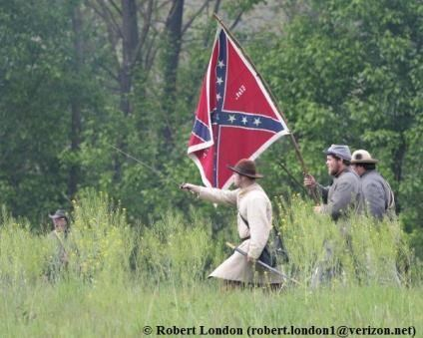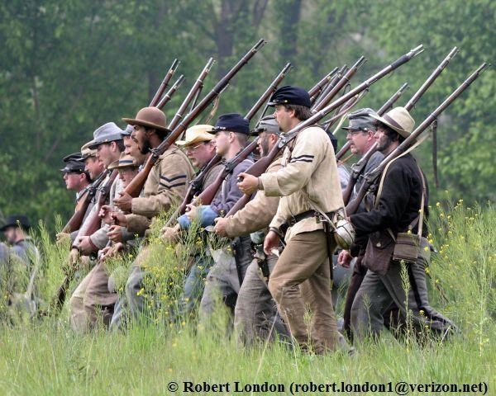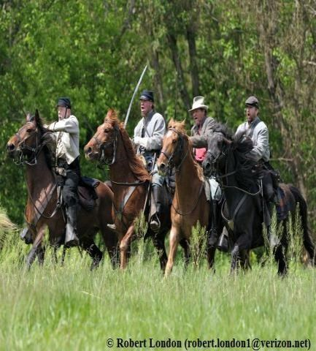

A BREIF HISTORY OF HUNTER’S RAID
During the Civil War, the Town of Buchanan served as an important Confederate supply depot for shipment of agricultural produce and pig iron to Richmond via the James River and Kanawha Canal. Buchanan Farmers provided the Confederate quartermaster with beef, cotton, yarn and corn. Buchanan also provided troops for the Confederate war effort, most notably for the Botetourt Artillery. The unit distinguished itself in the defense of Vicksburg.

Federal General David Hunter marched through Buchanan on June 13, 1864 on his ill-fated raid in Lynchburg. The following day Confederate General J.D. Imboden reported that Hunter had driven Confederate troops under McCausland’s command out of Buchanan. Period letters tell how McCausland burned the covered bridge over the James River before leaving igniting a fire which destroyed close to thirty buildings.

Personal letters of the era also tell of the devastation to Buchanan caused by the war including the burning of Col. John Anderson’s home known as Mount Joy, the three day Federal occupation of Oak Hill, the Anchorage, the Presbyterian Manse as well as other private homes and offices throughout Town. The battle flag of the Botetourt Artillery was said to have been made from the wedding dress of Cassandra Anderson, owner of Mount Joy.

April 28 – April 30, 2023 – Explore Living History Camps, stroll period demonstrations, Heritage Craft Demonstrations, Buchanan History Displays, Camp Bon Fire, Sunday Camp Church Services, Civil War History Films, Guest Speakers and more!

Amenities Provided: Free camping for re-enactors in the historic district or along the banks of the James River. Free water and firewood! Saturday evening meal for those who register by FRIDAY, MARCH 15, 2024

BOUNTIES – There will be FOUR bounties offered. Each bounty is in the amount of $200. The Bounties will be awarded to the first two Federal and first two Confederate units who register a Full Scale Field Cannon with 57” wheels. The Botetourt Artillery will pass the hat at the battle asking spectators to make donations before each battle to help with bounties for additional cannons. Amounts of additional bounties will be no more than $150 and will go to units in the order that they register. Please note, there is no guarantee of additional bounties.

FEES: A flat fee of $15.00 will be charged for each individual, and a $25 Fee for each Period Vendor or Sutler who pre-registers by FRIDAY, MARCH 15, 2024. Applications must be received in the Town Hall by this date, this does not include post mark. Children under12 $5.00 registration fee. A $50 fee will be charged to each vendor or settler who register after that date. Reenactors who register after FRIDAY, MARCH 15. 2024 will be charged $20 per person.
Make checks payable to: Town of Buchanan. ALL FEES ARE NON REFUNDABLE.

Hosted by the Town of Buchanan, the Botetourt Artillery Chapter of the Sons of Confederate Veterans,

Buchanan Civil War History Weekend

Event Rules

MANDATORY OFFICER’S MEETING ON SATURDAY, EVERY UNIT MUST ATTEND.
1.No pets.
2.No fireworks.
- No live ammunition.
- Period weapons only.
- Quiet after 10:00 PM.
- All vehicles out of camps and off of the Buchanan Town Park Lawn Areas by 8:00 am Saturday NO EXCEPTIONS.
- All participants are required to register upon arrival. All autos must have a pass on the dash to enter the reenactment site. All participants will be issued a Registration Wristband which must be worn during the activities.
- All uniforms and shoes must be of proper period materials and construction.
- No horses in civilian, infantry, artillery or sutler camps.
- Flags carried during engagements will be at the discretion of overall commanders.
- All modern equipment, packages or food are to be hidden.
- Only registered sutlers will be allowed to sell merchandise.
- This is a family oriented event. There is a zero tolerance for abuse, there are no illegal substances or alcohol allowed – violators will be referred to the local law enforcement agency. Rowdiness, abusive language or public drunkenness will not be tolerated. Unit commanders are responsible for all unit members – military and civilian.
- Minimum age to carry a weapon or service an artillery piece is 16. No one under 13 allowed on the field. Ages 13-15 must be functional musicians.
- All units are expected to bag all trash and deposit in park dumpster daily.
- No firearms are to be discharged in or near the camps under ANY circumstances.
- Infantry long arms should be loaded with a maximum of 70 grains of powder.
- No penny wrappers, staples, wads or tape are to be used for cartridges. Pre-rolled rounds only.
- No hand-to-hand or individual heroics. Direct aimed fire shall not take place within 40 yards and firing is not to take place within 20 yards. All weapons are to be inspected prior to battle. Safety inspections are mandatory.
- No unauthorized filming or video taping of our event for commercial purposes.
- Cut out sod and remove before digging fire pits: clean trash out of pits: replace sod before leaving.
- Commanders are responsible for getting information to their troops and are responsible for the conduct of their troops.
- No rank above captain on the field unless approved prior to event.
- Eyewear must be of period construction. No sunglasses of any type.
- Family and friends in camp are encouraged to dress the part. If not, they should depart at the end of the spectator’s day and not return until spectator hours commence the next day.
- Coggins paper for horses are to be current and will be inspected by cavalry commanders.
- Horses must remain on the Buchanan Town Park and are excluded from street activities.
- Please remember we are all guests of the Town of Buchanan.
- LEAVE NO TRACE BEHIND. Please place all garbage in the dumpster on the Town Park.
- NO PETS, strictly enforced.

